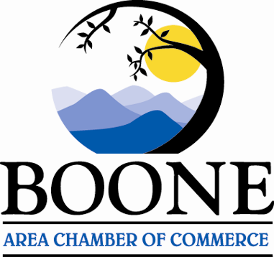 **BOONE AREA CHAMBER OF COMMERCE**

579 Greenway Rd; Suite 101

Boone, NC 28607

828-264-2225

[www.boonechamber.com](http://www.boonechamber.com)

E-mail: [david@boonechamber.com](mailto:david@boonechamber.com)

***Serving the Heart of the High Country***

**FOR IMMEDIATE RELEASE Contact: David Jackson, 828-264-2225**

**BOONE AREA CHAMBER OF COMMERCE FOUNDATION RECEIVES $35,000 CHALLENGE MATCH FROM ANONYMOUS DONORS FOR HURRICANE HELENE RELIEF EFFORTS**

*Funding will provide additional resources for short, medium, and long-term business support*

**BOONE, NC –** The **Boone Area Chamber of Commerce Foundation** is excited to announce an extraordinary opportunity for the community to double its impact thanks to a generous $35,000 challenge match from two local anonymous donors. This matching gift aims to support the Foundation's continued efforts in storm relief throughout the High Country brought on by Hurricane Helene.

For every dollar donated up to $35,000, the anonymous donors will match it, effectively doubling contributions and amplifying the impact of each gift. The funds raised will go toward supporting short-, medium-, and long-term strategies for business recovery in Boone and the surrounding High Country.

"We are incredibly grateful for the support of these generous donors during this critical time for our community," said **David Jackson, President and CEO of the Boone Area Chamber of Commerce.** "We’ve been fortunate that donor support thus far has helped the foundation take care of some immediate community needs. This matching challenge gives us an opportunity to raise more local dollars for relief efforts and to support the business community that has given so much to locals and visitors over the years."

The challenge match is active now, and donations can be made online through the Foundation’s website or by contacting the Boone Area Chamber of Commerce directly.

The Boone Area Chamber of Commerce Foundation is focused on helping with community and business relief in the aftermath of Hurricane Helene’s impact on the High Country. The Chamber will distribute funds locally to businesses and community efforts as needs are further assessed throughout Watauga County over the days and weeks ahead.

For more information on the challenge match or to donate, please visit www.boonechamber.com/foundation or contact Ethan Dodson at ethan@boonechamber.com.

**\*\*About the Boone Area Chamber of Commerce Foundation\*\***

The Boone Area Chamber of Commerce Economic Development Commission, Inc. (BACC EDC, Inc), also known as the Boone Area Chamber of Commerce Foundation, is a 501(c)3 organization created to solicit, manage, and distribute funds and resources to further the development and welfare of the Boone, NC and Watauga County, NC, area through activities which are exclusively charitable, educational, or scientific.